EXPERIMENT 10

SQL Query Generation using Structured Prompting

Name | N.Vinay Yadav
Register Number | 192472061

AIM
To demonstrate SQL query generation by providing a database schema and a clearly stated requirement.

PROCEDURE
- Define the Students table and its columns.
- Specify the requirement to display students scoring above 80 marks.
- Construct the SQL query based on the schema and requirement.
- Display the schema, requirement, and generated SQL query.
- Run the Python program and observe the output.

PROGRAM
print("SQL Query Generation using Structured Prompting")

schema = "Table: Students"
columns = "Columns: id, name, marks"
requirement = "Display students who scored above 80 marks." query = "SELECT * FROM Students WHERE marks > 80;"
print("\nDatabase Schema:") print(schema) print(columns)

print("\nRequirement:") print(requirement)

print("\nGenerated SQL Query:") print(query)

OUTPUT

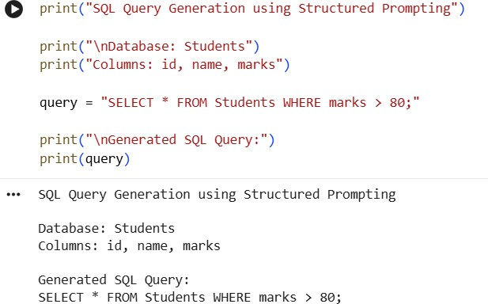

RESULT
Thus, the SQL query generation demonstration using structured prompting was completed successfully.

